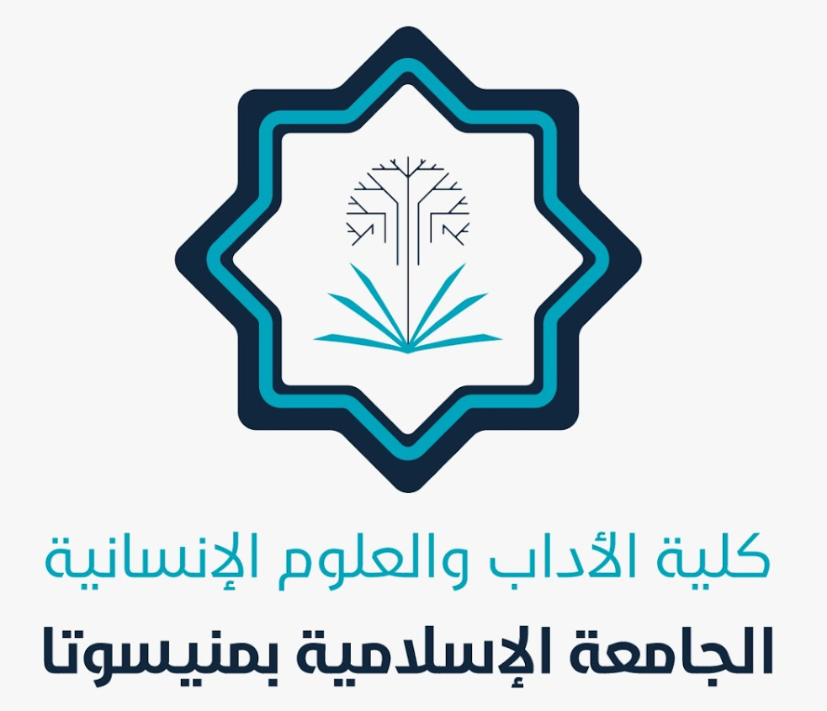
In the Name of Allah, the Most Gracious, the Most Merciful
Achievements of the Faculty of Arts and Humanities for
February 2025
- The final exams for the second semester commenced after thorough preparations by all university staff.
- Several new faculty members were appointed in the Departments of Political Science and English Language.
- The university held a ceremony to honor exemplary students in all departments.
- Numerous scientific and training courses and lectures were conducted.
- Outstanding faculty members were recognized and honored.
- A meeting was held between the Head of the English Language and Literature Department and the faculty members.
- Several meetings were conducted by the Deanship of Educational and Administrative Affairs.
- A workshop on self-confidence and self-management was organized.
- Certificates of appreciation were issued to all faculty members across all departments.
- Congratulations and best wishes were published on the occasion of the arrival of the holy month of Ramadan.

- All activities for the second semester concluded with the onset of Ramadan.
- Preparations for the summer semester are underway.
- Some faculty members published research on behalf of the university and were honored for their contributions.

Allah is the Grantor of Success

