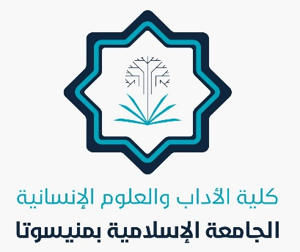
In the Name of Allah

Achievements of the College of Arts and Human Sciences
May 2025
Several achievements have been made in the college, including:
- Conducting six meetings for department heads.
- Hosting a poetry presentation course led by Dr. Muslim Al-Maliki, a faculty member in the Department of Arabic Language and Literature.
- Renewing some expired faculty appointment decisions.
- Uploading all summer exam links.
- Publishing clips, images, and announcements explaining how to navigate the new electronic portal.
- Uploading assigned courses.
- Successfully completing summer semester lectures without the need for any compensatory sessions, achieving a 100% success rate.
- Starting summer semester exams in all departments on Wednesday, 23 Dhul-Qi'dah (May 21), and concluding them on Wednesday, 1 Dhul-Hijjah (May 28).
- Congratulating the College of Arts administration for completing the summer semester for faculty, staff, and students.
- Issuing certificates of appreciation to both the dean and the vice-dean for their significant contributions to the college.
- Issuing certificates of appreciation to summer semester faculty members.
- Participating in a ceremony honoring exemplary students for the summer semester.
- Conducting a seminar to discuss a doctoral thesis by a student from the Department of Arabic Language and Literature.
- Discussing a doctoral thesis submitted by a student from the Department of History and Antiquities.
- Preparing for the discussion of the thematic seminar for another doctoral student's plan in the same department.
- Assigning two faculty members from the Department of Political Science to the Department of History and Antiquities.
- Forming several committees for the university book project.
- Preparing for the first semester of the upcoming academic year 2025.

Allah is the Grantor of Success.

