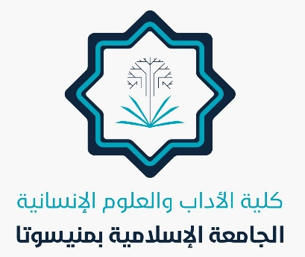
In the Name of Allah

Achievements of the College of Arts and Humanities
March 2025

Several achievements have been made in the college, including:

- Resumption of university forum activities.
- Completion of final exam grade recording for the second semester.
- Launch of supplementary exams.
- Meetings of department heads with faculty members.
- Preparation for the summer semester.
- Opening of summer course groups.
- Publication of summer semester schedules.
- Establishment of a formal study department in the History and Archaeology Department.
- Honoring professors who published research under the university's name, along with issuing certificates of appreciation.
- Participation in university celebrations to honor the secretaries.
- Issuance of a statement regarding the number of students in undergraduate and graduate programs.
- Honoring the college secretary and department secretaries.
Allah is the Grantor of Success.

