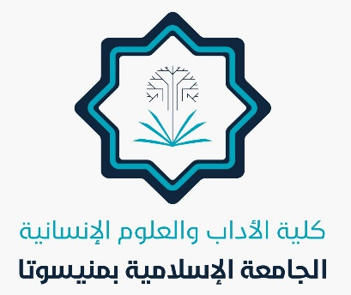
In the Name of Allah

Achievements of the College of Arts and Humanities
APRIL 2025

Several achievements have been made in the college, including:

- The summer semester commenced following intensive preparations during the holy month of Ramadan.
- Summer semester students were welcomed and received.
- Four meetings were held for department heads among the teaching staff.
- The new electronic portal was launched, along with efforts to share its links and explain how to access and utilize its new features.
- New self-learning groups were opened in the Department of Arabic Language and Literature.
- A research proposal was discussed in the Department of History and Archaeology.
- A research proposal was discussed in the Department of Arabic Language and Literature.
- Participation in the university celebrations honoring top students of the second semester and congratulating them.
- Creating exam links for the summer tests across all departments.
- Preparing schedules for self-learning.
- Launch of the Poetry Meter Course, organized by the University Creativity Forum and presented by Dr. Muslim Al-Maliki — a faculty member of the Arabic Language and Literature Department — under the supervision of the department head, Dr. Osama Abdulrahman, and the coordination and supervision of Associate Professor Dr. Sahar.
Allah is the Grantor of Success.

