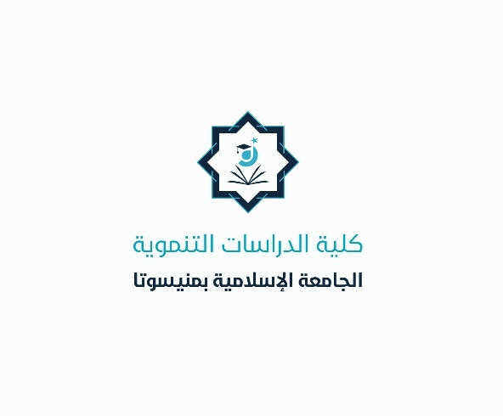



- **Dr. Musab was exempted from participating in the thesis pathway discussion** **with the student.**

**- Three students** **were transferred from the regular track to the thesis track.**

- **A thesis discussion was held with master’s student Khaled in Development** **Management.**

- **Dr. Yousef Bani Younes was promoted from Assistant Professor to Associate** **Professor.**

- **The appointment of Dr. Iman Al-Badri** **was renewed.**

**.**

- **The appointment of Dr. Iman Al-Badri was renewed.**

**- An administrative affairs meeting was held, chaired by Dr. Norhan and Ms. Maha.**

- **Dr. Iman Al-Gundi was relieved from her position as Deputy Head of the Development Management Department, and Dr. Mohammed Al-Jabbali was appointed as her** successor.

**\*Achievements of the College of Developmental Studies for August 2025\***

**0**

**00**

**0**

**000**

**000**